How to create mind maps with NotebookLM



Alex McFarland
Apr 03, 2025
∙ Paid

If you've been creating content for any length of time, you've felt that frustrating disconnect between all your existing content, sources, and ideas. Or maybe you struggle to repurpose one piece of content into multiple others.
This is precisely why the new mind map feature from NotebookLM is such a revelation for content creators.
Google just released this feature a few days ago, and I'm already convinced it's one of the most powerful AI research tools for writers in 2025.
NotebookLM automatically generates comprehensive mind maps from your sources. The AI analyzes your content, extracts key concepts, and maps relationships between ideas in seconds—showing you connections you might never have discovered on your own.
This is perfect for:
- Content creators looking to maximize existing material
- Researchers trying to synthesize multiple sources
- Writers planning structured content
- Anyone trying to extract maximum value from their content library

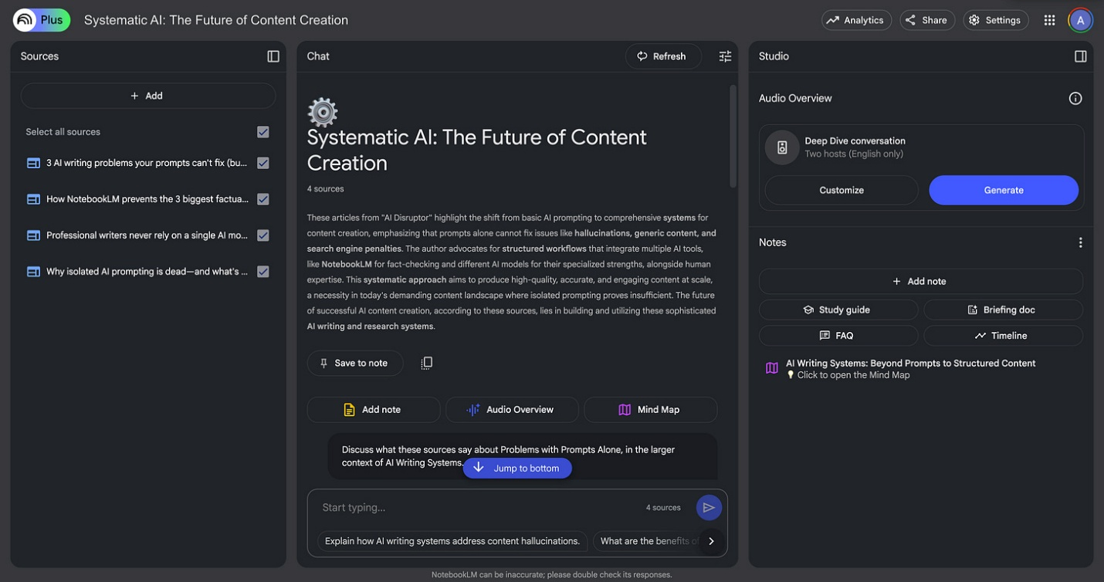

Subscribed

Creating your first mind map
Getting started is incredibly simple. Here's how:
- Upload a source to NotebookLM (article, PDF, or paste text)
- Click "Create a mind map" in the right sidebar
- Within seconds, you'll have a complete visualization

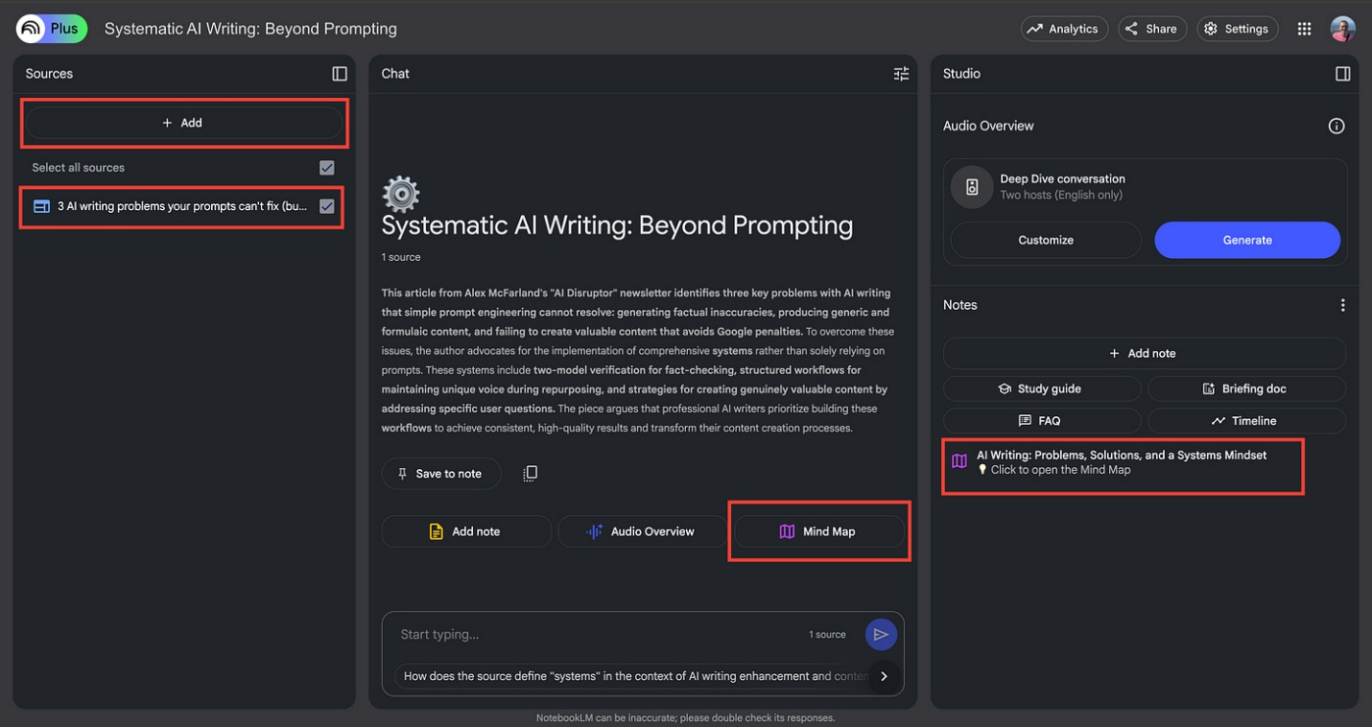

The system automatically identifies the main theme of your content and branches out into subtopics and related concepts. For example, when I uploaded my newsletter on "3 AI writing problems prompts can’t fix (but systems can)," the mind map instantly organized it into logical branches.

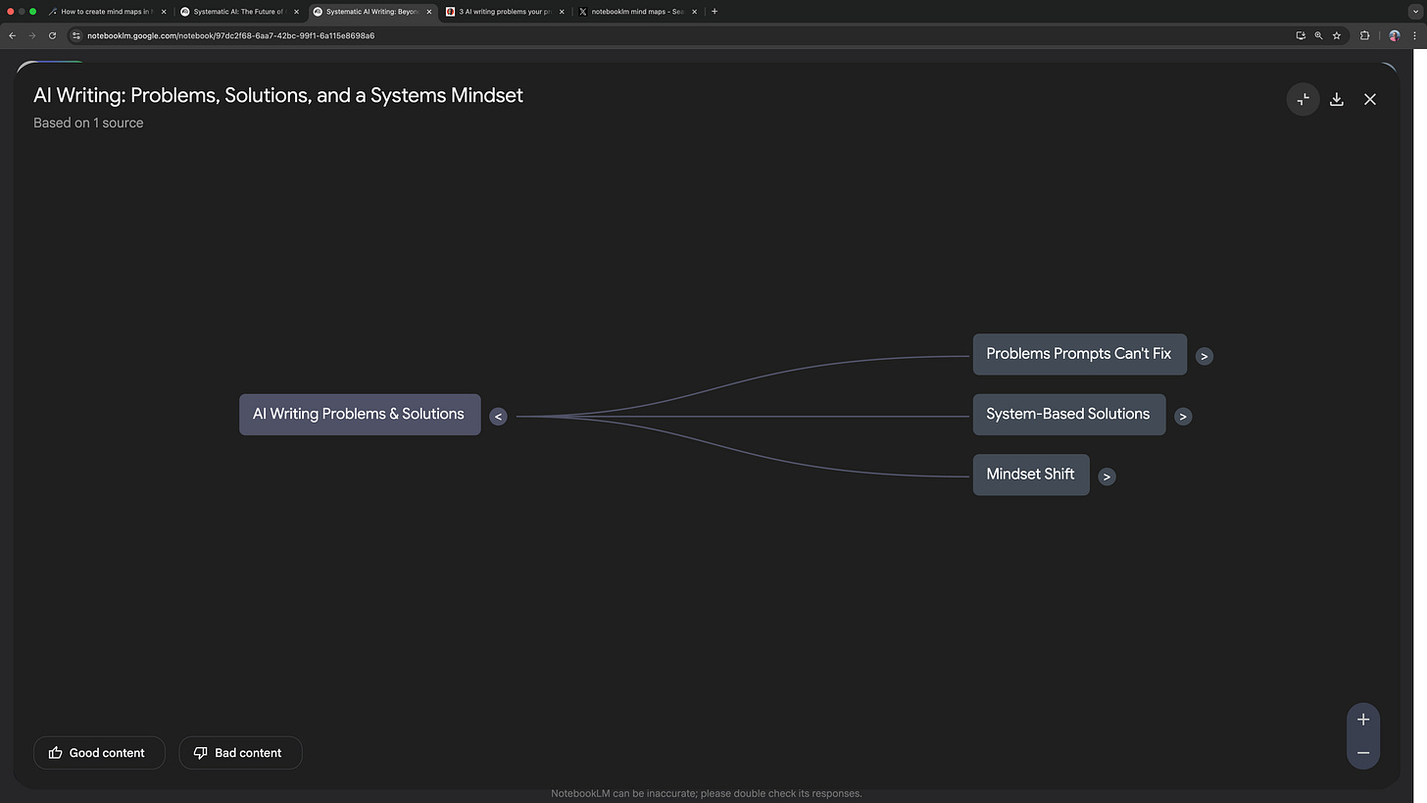

The beauty is in how you can click any branch to expand it further, revealing even more detailed concepts. This gives you an immediate visual overview of your entire piece while allowing you to drill down into specific areas.

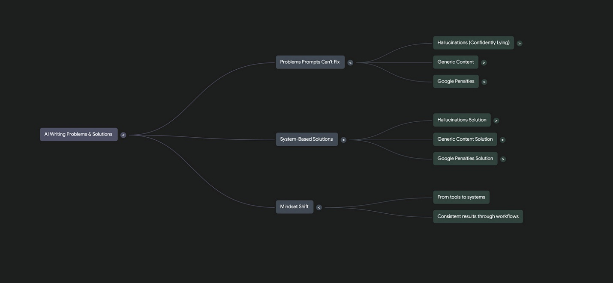

POLL
How do you currently organize your content research?
Dedicated mind mapping software
Outlines and notes
I just keep it all in my head
I have no system (help!)

Multi-source mind mapping
Where this tool truly shines is when you combine multiple sources.
I tested this by uploading five of my recent newsletters about AI writing systems. NotebookLM instantly analyzed them all and created a comprehensive mind map that showed:
- Shared concepts across all five pieces
- Logical groupings of related ideas
- Hierarchical relationships between topics
- Subtopics I hadn't consciously connected before
This level of synthesis would take hours manually but happens in seconds with NotebookLM.

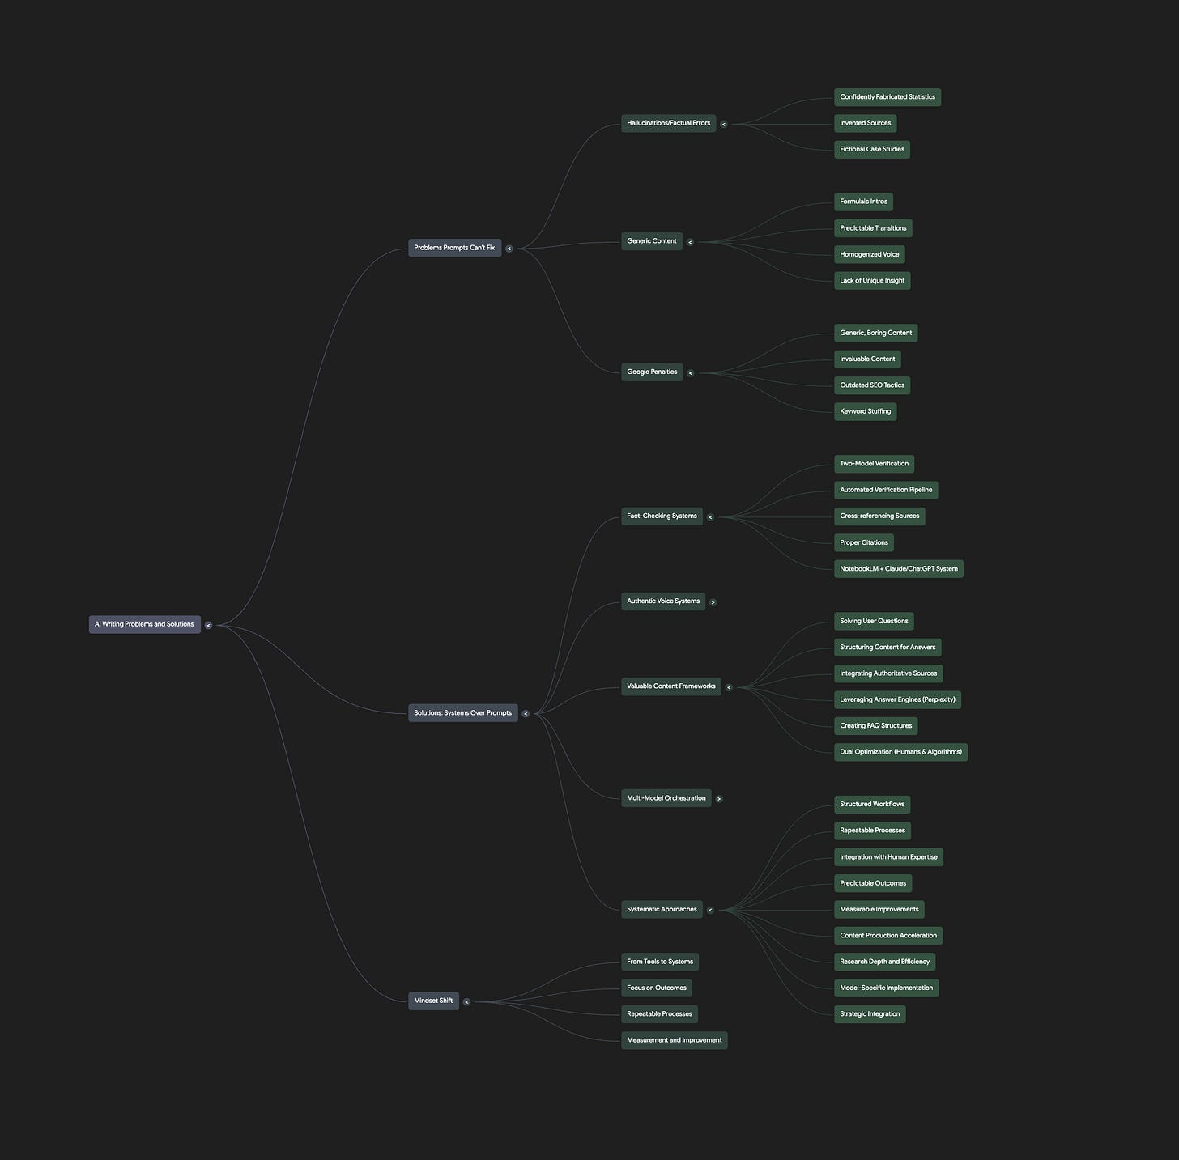

4 powerful use cases for content creators
1. Extract shared concepts across sources
Find the hidden connections between seemingly disparate content. When you upload multiple sources, NotebookLM identifies common themes and creates branches that show how different pieces of content relate to each other.
This is invaluable for seeing patterns in your work and identifying your strongest recurring ideas.
2. Generate endless content topics
Turn one piece of content into a dozen new ideas. Each branch and sub-branch on your mind map represents a potential standalone piece. What might have been a single paragraph in your original content could become an entire article, newsletter, or video.
A single newsletter can turn it into countless additional pieces of content.
3. Create structured content outlines effortlessly
Each major branch in your mind map can become a section heading, with sub-branches forming your subheadings. This gives you an instant, logically-structured outline for new content based on your existing work.
This is particularly valuable when repurposing complex topics into new formats—like turning a technical article into an accessible guide.
4. Develop targeted social media content
Click any node in your mind map to generate a detailed brief about that specific topic. NotebookLM will pull together relevant information from all your sources on that particular subject, creating the perfect foundation for social media posts.
You can easily transform these briefs into threads, posts, Substack notes, or short-form content with minimal additional work.

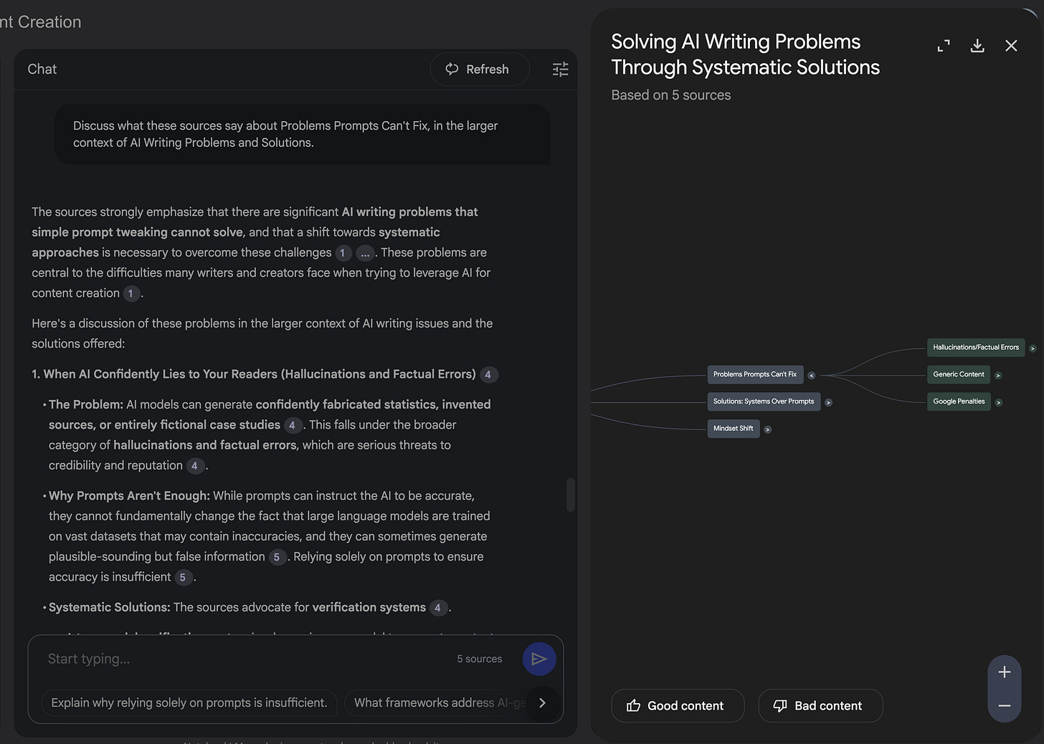

Building this into your workflow
The best part? NotebookLM (including the mind map feature) is completely free. You can start using it immediately with just a Google account.
I recommend trying it with:
- A single piece of your best-performing content
- A collection of 3-5 related pieces you've created
- Research material for your next big project
This tool fits perfectly into a systematic approach to content creation—exactly what I've been advocating. It provides the visual organization layer that's been missing from most AI writing workflows.
You now have a centralized way to visualize, organize, and extract maximum value from your research and existing content.

